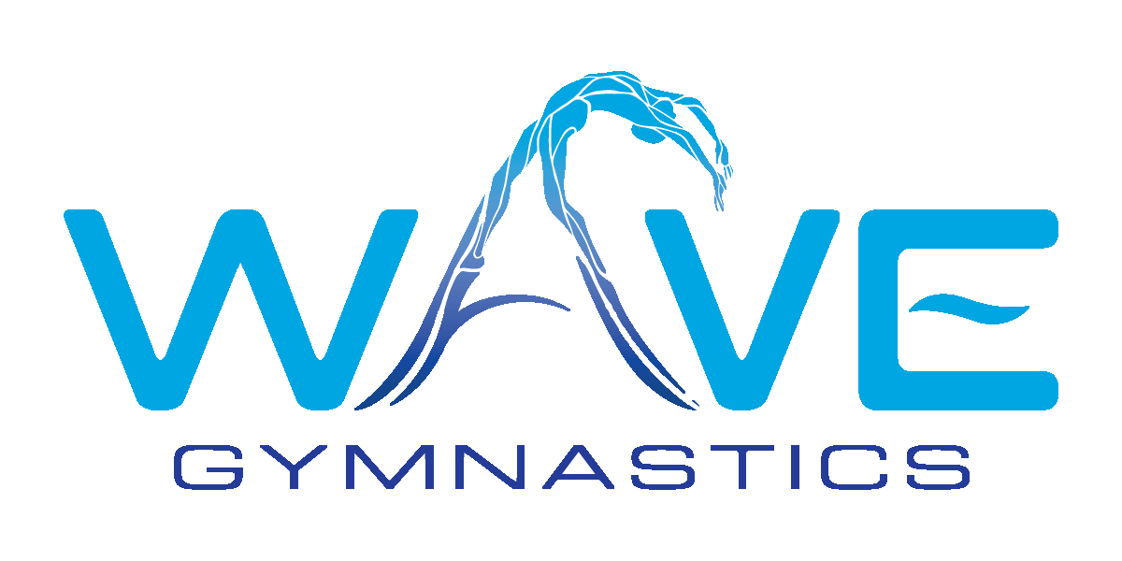
SUMMER 2024 GYMNASTICS CAMPS & CLINICS
Our summer gymnastics program is a great introduction or continuation to learn the fundamental basics of balance beam, vault, uneven bars, floor exercise as well as trampoline. Students will work towards improving their skills while gaining overall strength, balance and flexibility in the sport of gymnastics. This program is great for beginning gymnasts curious about the sport as well as for those interested in competing!

Gymnastics Clinics Accelerate & perfect your gymnastics skills with our summer clinics. Clinics include all four Olympic events plus trampoline, flexibility, strength training and more!
Girls Ages 5-18
9:00am-11:00am
$50/day
Thursday June 13, June 27, July 11, July 25

Drop & Roll
We provide a safe and fun environment for children to have fun with their peers as they experience a variety of gymnastics equipment. Here they will build confidence and work on learning new skills and perfecting ones they already have!

Girls & Boys Ages 4-7
9:00am-12:00pm
$50/day
Monday June 25,
Monday July 8, Monday July 27

Themed Summer Camps
Our recreational gymnastics camps are filled with gymnastics, athletic games, arts & crafts, foam pits, music, fun and more!

Girls & Boys Ages 4-11
9:00am-12:30pm
$279/week

Under the Sea
June 17-June 21

Circus Acro
July 15-19

Outerspace
July 29-August 2

Don't let your children miss out on these fun summer gymnastics adventures! Space is limited, call or email us today to reserve your spot! (949)397-9283 wavegymnasticsoc@gmail.com

Check us out on IG @wavegymnasticsoc

